NLP Sentiment Analysis Report
Author A
114423002 · jjwang1118@gmail.com
github.com/jjwang1118/positivie_negative_NLP
Abstract
This study uses the Kaggle dataset "Positive/Negative: Text Polarity Classification 26" to address a binary sentiment classification task (positive/negative) under a severely data-scarce setting: only 1,600 labeled samples and 11,000 unlabeled test samples. The insufficient labeled data makes models prone to overfitting with limited generalization ability. How to effectively leverage the large unlabeled test set through pseudo-labeling strategies thus becomes the core research problem. Using RoBERTa-large as the backbone, this study designs and compares two pseudo-labeling strategies: EXP01 adopts a three-stage progressive encoder unfreezing pipeline — Stage 1 freezes the entire encoder and trains only the classification head to establish a stable initial model, while Stages 2–3 progressively unfreeze the last three encoder layers and use a confidence threshold (0.90) to filter pseudo-labels for training set augmentation; EXP02 adopts a two-stage strategy — Phase 0 trains a warm-up model on all labeled data and generates pseudo-labels for the full 11,000 test samples (no confidence threshold), and Phase 1 trains a 5-fold model using each fold's labeled data plus all pseudo-labels, with balanced class weights and Early Stopping. Experimental results show that EXP02 outperforms EXP01 across all metrics (val accuracy: 0.8805 vs. 0.8315; F1: 0.8810; std: 0.0153 vs. 0.0163; public test: 0.77988 vs. 0.77465; private test: 0.79864 vs. 0.77815), indicating that under the current experimental configuration, EXP02's combined strategy achieves stronger overall performance than EXP01 on the reported evaluation metrics.
Keywords: Binary Classification, Sentiment Analysis, Pseudo-Labeling, RoBERTa, Self-Training, Progressive Unfreezing, Semi-Supervised Learning, Text Feature

1. Introduction
Sentiment analysis is one of the core tasks in natural language processing (NLP), widely applied in public opinion monitoring, product review analysis, and social media understanding. Its goal is to automatically identify the sentiment orientation expressed in text — in the case of binary classification, to determine whether a piece of text conveys a positive or negative sentiment. Although pre-trained language models (PLMs) represented by BERT have greatly improved performance on such tasks in recent years, in practical scenarios the acquisition of manually labeled data is often costly. How to fully exploit the potential of models under limited labeled samples remains an important research challenge.
This study uses the Kaggle competition dataset "Positive/Negative: Text Polarity Classification 26." The task is to perform binary sentiment classification on given texts, where label 1 represents positive sentiment and label 0 represents negative sentiment. The dataset contains 1,600 labeled training samples and 11,000 unlabeled test samples, with a severely imbalanced data scale. Preliminary analysis reveals a class imbalance in the training set (more positive samples than negative) and noise in some texts — specifically, split contractions such as "can t" (should be "cannot"), "i m" (should be "i am"), and "won t" (should be "will not"). If these split contractions are not corrected, the tokenizer will fail to properly interpret the semantics, further increasing the difficulty of model learning. Under these conditions, directly fine-tuning all encoder parameters is highly prone to overfitting given the scarcity of labeled samples, severely limiting the model's generalization ability.

Figure 1. EXP01 training pipeline (exp09-05).
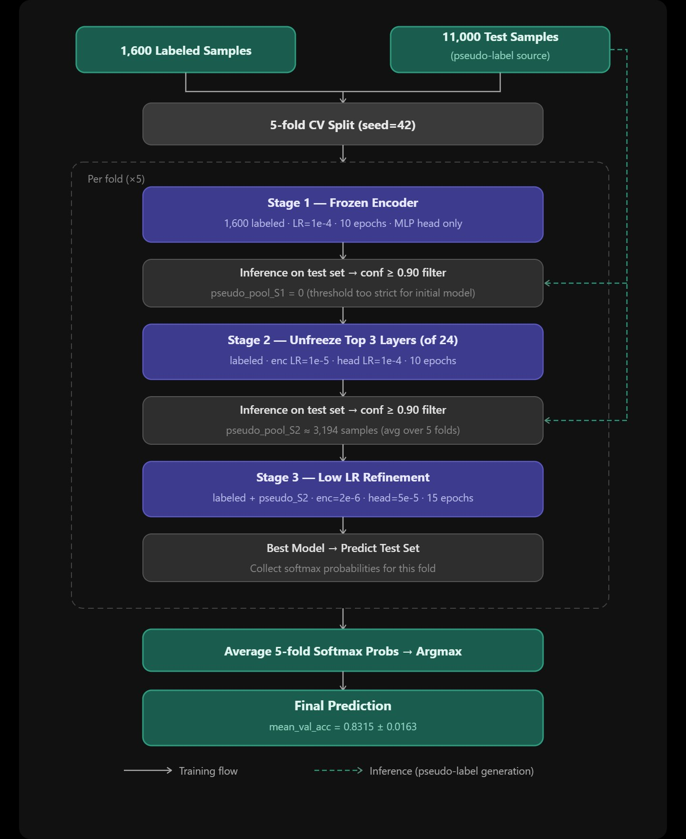

Facing these challenges, the core research question is: how to effectively leverage the large unlabeled test set to augment training data and improve model generalization under low-resource conditions. The pseudo-labeling strategy in semi-supervised learning provides a viable path — first train an initial model on limited labeled data, then predict unlabeled samples and add high-confidence predictions as pseudo-labels back into the training set, iteratively strengthening model performance. However, the quality of pseudo-labels and the timing of their introduction have a substantial impact on the final result; introducing low-quality pseudo-labels too early may cause error accumulation, while overly strict filtering leaves too few pseudo-labels to provide effective benefit.

Figure 2. EXP02 training pipeline (exp11-01).
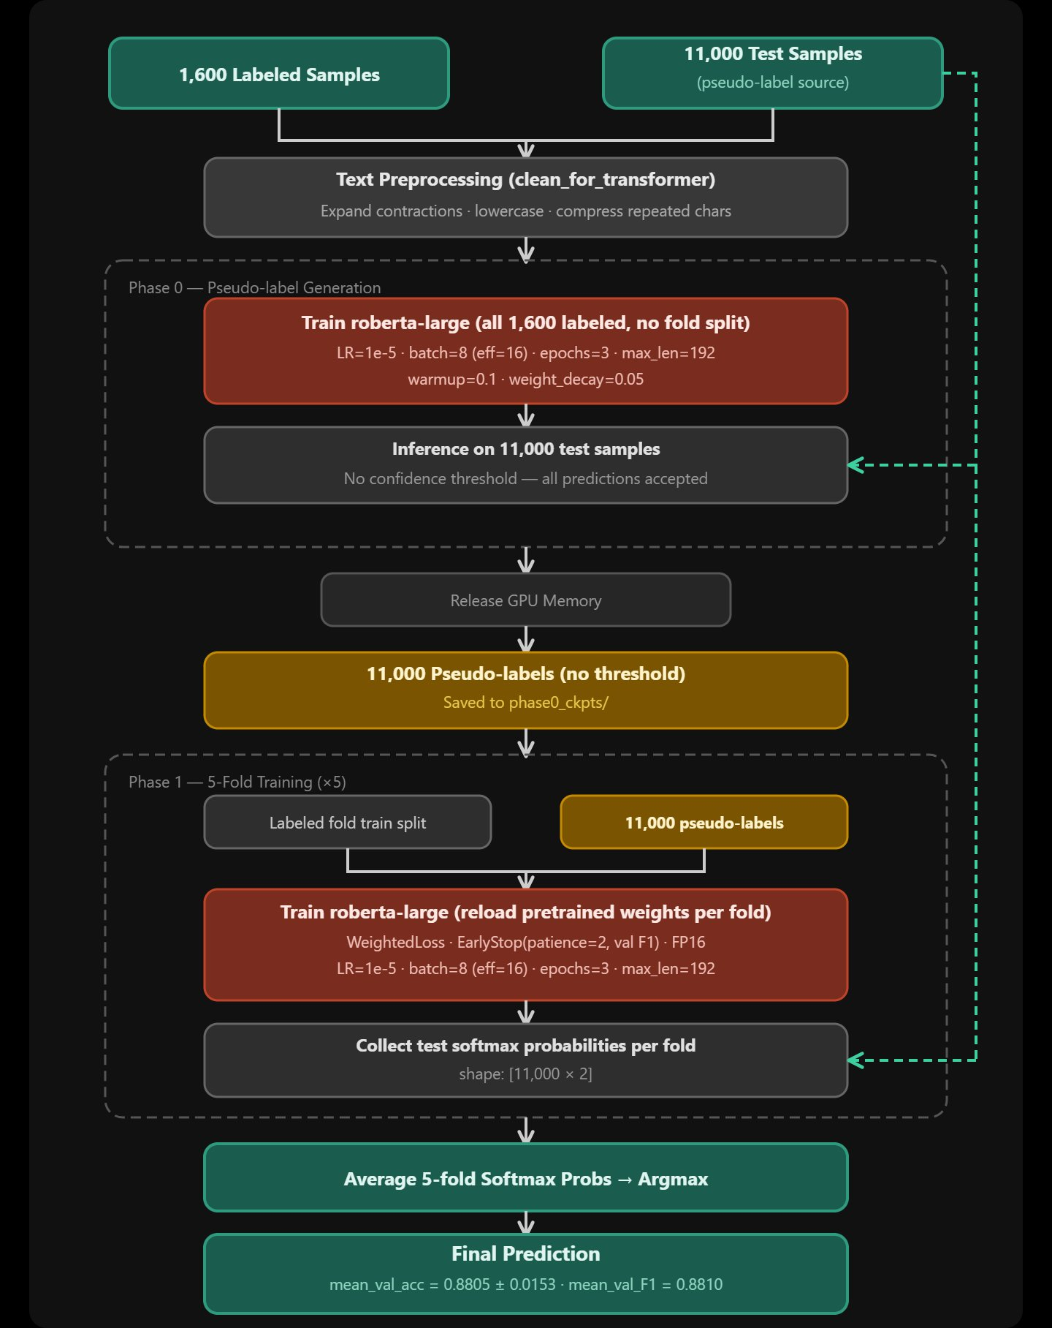

To investigate the effects of different pseudo-labeling strategies on this task, this study designs and compares two RoBERTa-large-based training schemes: EXP01 (Figure 1) adopts a three-stage progressive unfreezing pipeline — Stage 1 freezes the encoder to build a stable initial classifier and uses a confidence threshold (0.90) to filter pseudo-labels, while Stages 2–3 progressively unfreeze the last three encoder layers for fine-tuning; EXP02 (Figure 2) adopts a two-stage strategy — Phase 0 trains a warm-up model on all labeled data to generate full pseudo-labels for the test set (no filtering threshold), and Phase 1 trains using each fold's labeled data plus all pseudo-labels with balanced class weights and Early Stopping for training stability. Both experimental schemes use 5-fold cross-validation to ensure result stability. The differences are concentrated in the pseudo-labeling strategy and encoder unfreezing approach.
2. Methodology
2.1 Experiment Overview
This study designs two semi-supervised training schemes centered on pseudo-labeling, both using RoBERTa-large as the backbone and evaluated with 5-fold cross-validation. The core concept of EXP01 is Progressive Unfreezing combined with Self-training: through three training stages, the encoder is first frozen to build a stable classification head, then the last three encoder layers are progressively unfrozen, and pseudo-labels filtered by confidence threshold are incrementally added to the training data. EXP02 adopts a more direct full pseudo-label strategy: Phase 0 generates 11,000 pseudo-labels from full test-set predictions by the warm-up model, which are then directly incorporated in the 5-fold training of Phase 1, with balanced class weights and Early Stopping controlling training stability. The primary difference between the two lies in the pseudo-label filtering strategy and the encoder unfreezing approach.
To ensure reproducibility, both schemes fix the random seed (seed = 42) and call set_seed() before training, sequentially setting random seeds for Python random, NumPy, and PyTorch (CPU and CUDA). EXP01 additionally sets torch.backends.cudnn.deterministic = True and torch.backends.cudnn.benchmark = False to eliminate non-determinism in CUDA convolution operations; EXP02 passes the seed through HuggingFace TrainingArguments(seed=42) into the Trainer framework. The 5-fold splits in both schemes use StratifiedKFold(random_state=42) to ensure consistent fold assignments across runs.
2.2 Data Preprocessing
EXP01 performs no text cleaning and feeds raw text directly to the model. EXP02 applies text normalization before loading data, correcting common split-contraction noise in the dataset. Since contractions in some texts were broken during collection (e.g., "can t" should be "cannot", "i m" should be "i am"), leaving them uncorrected would prevent the tokenizer from properly interpreting contraction semantics, degrading feature extraction quality. EXP02 therefore uses regular expressions to restore common negative contractions, personal pronoun contractions, and auxiliary verb contractions to their full forms, converts all text to lowercase to eliminate case differences, and collapses repeated characters (e.g., "loooove" → "loove") to reduce surface noise. Detailed correction rules are listed in Appendix C.
2.3 Model Selection
Table 1. Backbone model comparison (preliminary runs)
Item | siebert (run02) | roberta-large (run05)
Pre-training | Sentiment-specialized | General-purpose MLM
Parameters | ~355M | ~355M
Mean val acc | 0.8565 (std=0.0094) | 0.8315 (std=0.0163)
Kaggle public | 0.74490 | 0.77465
Val→pub. gap | ~0.1115 (overfitting) | ~0.057 (better)
Pipeline compat. | Low | High

Early experiments compared two candidate backbone models: siebert/sentiment-roberta-large-english [2] and roberta-large [1]. The former is a fine-tuned version of RoBERTa-large on large-scale sentiment classification datasets, theoretically possessing stronger sentiment semantic understanding; the latter is a general-purpose pre-trained model trained with Masked Language Modeling (MLM), with a more complete and malleable language representation space. As shown in Table 1, early experiments using siebert as the backbone (run02) achieved a higher validation accuracy (0.8565), but the Kaggle public score was only 0.74490, a gap of 0.1115, indicating severe overfitting. In contrast, switching to roberta-large (run05) reduced validation accuracy slightly to 0.8315 but improved the Kaggle public score to 0.77465, narrowing the val-to-public gap to 0.057 and significantly improving generalization. Therefore, roberta-large was adopted as the shared backbone for both schemes.
2.4 EXP01 — Self-training + Progressive Encoder Unfreezing
(See Figure 1: EXP01 training pipeline)
The core design philosophy of EXP01 is to reduce overfitting risk through a "stabilize first, then expand" progressive strategy under severely data-scarce conditions. The overall training is divided into three stages, with pseudo-labels generated from model predictions on the test set between stages to gradually augment training data. All stages are executed independently under a 5-fold cross-validation framework, with the final predictions being the average softmax probabilities of the best model from each fold.
2.4.1 Model Architecture
EXP01 adds a custom classification head on top of the roberta-large encoder: Linear(1024→64) → ReLU → Dropout(0.1) → Linear(64→2). The intermediate layer compresses the 1,024-dimensional encoder output to 64 dimensions, uses ReLU as the activation function to introduce non-linear modeling capacity, and applies Dropout(0.1) to suppress overfitting. This lightweight bottleneck design is especially critical in Stage 1 when the encoder is frozen: limiting trainable parameters prevents the classification head from memorizing training noise in a low-data setting.
2.4.2 Training Pipeline (3 Stages × 5-fold CV)
Stage 1 — Frozen Encoder. Stage 1 freezes all roberta-large encoder layers and trains only the classification head on 1,600 labeled samples (LR = 1e-4, epochs = 10, max_length = 128, label smoothing = 0.1, warmup ratio = 0.1). This stage serves two purposes: first, to build a stable initial classifier without corrupting pre-trained representations; second, to predict the 11,000 test samples and filter those with softmax confidence ≥ 0.90 as the first batch of pseudo-labels (pseudo_pool_S1). Due to the strict 0.90 threshold being too demanding for the Stage 1 initial model, pseudo_pool_S1 was 0 samples for all folds in this experiment. Stage 2 effectively begins training on pure labeled data.
Stage 2 — Unfreeze Last 3 Layers. Stage 2 unfreezes the last 3 Transformer encoder layers of roberta-large (out of 24 total) and fine-tunes with layer-wise learning rates (encoder LR = 1e-5, head LR = 1e-4, epochs = 10, max_length = 128, label smoothing = 0.1, warmup ratio = 0.1). The encoder LR is set to 1/10 of the head LR, allowing the upper encoder representations to gradually adapt to the sentiment distribution of this dataset while avoiding catastrophic forgetting. Upon completion, predictions are made on all 11,000 test samples and those with confidence ≥ 0.90 are selected as pseudo_pool_S2 for Stage 3.
Table 2. Pseudo-label volume from Stage 2 per fold
Fold | n_pseudo_S2
0 | 3,040
1 | 3,036
2 | 2,879
3 | 3,563
4 | 3,451
Mean | 3,193.8

Stage 3 — Low-LR Refinement. Stage 3 uses the best weights from Stage 2 as the warm-start, applying lower learning rates (encoder LR = 2e-6, head LR = 5e-5, epochs = 15, warmup ratio = 0.05) for final refinement of the entire model. Training data consists of 1,600 labeled samples plus pseudo_pool_S2 (average 3,194 samples). No new pseudo-labels are generated; the goal is to converge to a better local optimum on the existing training data.
2.4.3 Pseudo-label Strategy & Ensemble
EXP01 uses confidence-threshold filtering (confidence ≥ 0.90) to incorporate only the model's most confident predictions, maintaining pseudo-label quality. However, in Stage 1 the initial model performance was too limited for all folds to produce any pseudo-labels (pseudo_pool_S1 = 0), effectively making Stage 2 equivalent to training on labeled data only. Effective pseudo-label incorporation was not achieved until after Stage 2, providing an average of ~3,194 additional training samples per fold. Each fold independently completes three training stages and outputs softmax probability distributions on the test set using its Stage 3 best model. Final predictions are obtained by averaging the softmax probabilities sample-wise across all 5 folds, then applying argmax. This ensemble strategy leverages the complementarity of models trained on different data splits to reduce random error from any single fold partition.
For complete hyperparameter values, the run02 → run03 → run05 evolution, and the rationale behind each setting, see Appendix A (per-stage details and rationale) and Appendix D (three-run comparison table).
2.5 EXP02 — Phase 0 Pseudo-label + 5-fold Ensemble
(See Figure 2: EXP02 training pipeline)
The core design philosophy of EXP02 is to fully utilize the 11,000 unlabeled test samples with minimal complexity. The overall training is divided into two stages: Phase 0 trains a warm-up model on all labeled data and generates full pseudo-labels; Phase 1 then trains a 5-fold model using each fold's labeled data plus all pseudo-labels, with balanced class weights and Early Stopping to control training quality.
2.5.1 Model Architecture
EXP02 loads roberta-large via HuggingFace AutoModelForSequenceClassification, using the default RobertaClassificationHead (Dropout → Linear(1024→1024) → Tanh → Dropout → Linear(1024→2)), trained with FP16 mixed precision to save GPU memory. Compared to EXP01's custom lightweight classification head, EXP02 maintains the default full-dimension head and uses the HuggingFace Trainer framework, reducing the complexity of custom code. EXP02 applies text normalization when reading data: lowercase, contraction correction, and repeated-character compression (see Appendix C for rules).
2.5.2 Training Pipeline (2 Phases × 5-fold CV)
Phase 0 — Pseudo-label Generation. Phase 0 trains roberta-large on all 1,600 labeled samples without fold splitting (LR = 1e-5, batch size = 8, gradient accumulation = 2, effective batch = 16, epochs = 3, max_length = 192, warmup ratio = 0.1, weight decay = 0.05). After training, predictions are made on all 11,000 test samples without a confidence threshold — all predictions are directly used as pseudo-labels. GPU memory is released immediately after Phase 0 before entering Phase 1.
Phase 1 — 5-fold Training. Phase 1 trains each fold using labeled_fold_train (~1,280 samples) plus the 11,000 pseudo-labels generated in Phase 0 (same hyperparameters as Phase 0). Training uses balanced class weights (WeightedTrainer) to handle class imbalance, and EarlyStoppingCallback (patience = 2, monitoring val F1) to prevent overfitting, saving the best checkpoint each epoch.
2.5.3 Pseudo-label Strategy & Ensemble
EXP02 discards confidence-threshold filtering and directly incorporates all 11,000 full predictions from the Phase 0 warm-up model as pseudo-labels into Phase 1 training. The core rationale is that while focusing on high-confidence samples ensures pseudo-label quality, overly strict filtering under severely data-scarce conditions actually limits the augmentation benefit. Although full incorporation includes some low-confidence pseudo-labels, roberta-large's overall prediction quality is sufficient to serve as a weak supervision signal, and class weights combined with Early Stopping can further mitigate the negative impact of lower-quality pseudo-labels. Ensemble is identical to EXP01: 5-fold softmax average then argmax.
For complete hyperparameter values and the rationale behind each setting, see Appendix B (Phase 0/1 details and rationale) and Appendix E (EXP01 vs EXP02 full comparison table).
3. Results
3.1 Shared Settings
Table 3. Shared experimental settings
Item | EXP01 | EXP02
Base model | roberta-large | roberta-large
Seed | 42 | 42
CV | 5-fold Stratified | 5-fold Stratified
Primary metric | Accuracy | Accuracy + F1
Class balancing | — | Balanced class weights
Early stopping | None | patience=2 (val F1)
Label smoothing | 0.1 | None

As shown in Table 3, both schemes use roberta-large as the backbone, 5-fold Stratified CV as the validation framework, and fix the random seed (seed=42) for reproducibility. The main differences lie in class imbalance handling, Early Stopping configuration, and Label Smoothing usage.
3.2 EXP01 Per-Fold Results
Table 4. EXP01 per-fold validation results
Fold | S1 Acc | S2 Acc | Best Val Acc | n_pseudo_S2
0 | 0.7550 | 0.8325 | 0.8325 | 3,040
1 | 0.7650 | 0.8225 | 0.8425 | 3,036
2 | 0.7475 | 0.7875 | 0.8000 | 2,879
3 | 0.7400 | 0.8225 | 0.8375 | 3,563
4 | 0.7300 | 0.8300 | 0.8450 | 3,451
Mean | 0.7475 | 0.8210 | 0.8315 | 3,193.8
Std | — | — | 0.0163 | —

As shown in Table 4, EXP01's Stage 1 accuracy per fold ranges from 0.730 to 0.765, indicating limited initial performance when the encoder is frozen. After unfreezing the last 3 layers in Stage 2, per-fold accuracy improved substantially (0.788–0.833), with a final mean Best Val Acc of 0.8315 (std = 0.0163). Notably, pseudo_pool_S1 was 0 for all folds; pseudo-labels were only generated from Stage 2, providing an average of ~3,194 additional training samples per fold. Fold 2 performed noticeably lower (0.8000), resulting in a relatively larger overall standard deviation. Kaggle public score: 0.77465, private score: 0.77815.
3.3 EXP02 Per-Fold Results
Table 5. EXP02 per-fold validation results
Fold | Val Acc | Val Loss | Val F1
0 | 0.8725 | 0.6221 | 0.8765
1 | 0.9025 | 0.4379 | 0.9051
2 | 0.8650 | 0.6580 | 0.8670
3 | 0.8675 | 0.4105 | 0.8630
4 | 0.8950 | 0.4358 | 0.8934
Mean | 0.8805 | — | 0.8810
Std | 0.0153 | — | —

As shown in Table 5, EXP02's per-fold validation accuracy ranges from 0.865 to 0.903, with a mean Val Acc of 0.8805 (std = 0.0153) and mean Val F1 of 0.8810. Fold 1 performed best (0.9025), while Fold 2 was relatively lower (0.8650) but still outperformed all EXP01 folds. The overall standard deviation (0.0153) is slightly lower than EXP01 (0.0163), indicating more consistent performance. Kaggle public score: 0.77988, private score: 0.79864.

3.4 Overall Comparison
Table 6. Comprehensive comparison of EXP01 vs. EXP02
Item | EXP01 | EXP02
Mean Val Acc | 0.8315 | 0.8805
Val Acc Std | 0.0163 | 0.0153
Mean Val F1 | — | 0.8810
Kaggle public | 0.77465 | 0.77988
Kaggle private | 0.77815 | 0.79864
Pseudo-label vol. | ~3,194 (Stage 2) | 11,000 (full)
Conf. threshold | 0.90 | None
Enc. unfreezing | Last 3 layers (S2+) | Full (Ph. 0 & 1)
Training stages | 3×5 folds | 2×5 folds

As shown in Table 6, EXP02 achieves stronger overall performance than EXP01 on the reported comparable evaluation metrics: validation accuracy improved by 4.9 percentage points (0.8805 vs. 0.8315), while the Kaggle private score improved by approximately 2.05 percentage points (0.79864 vs. 0.77815). In EXP01, the overly strict Stage 1 confidence threshold resulted in zero Stage 1 pseudo-labels (pseudo_pool_S1 = 0), meaning that Stage 2 was effectively trained only on labeled data. This weakened the intended benefit of the multi-stage pseudo-labeling design.
4. Conclusion
This study designs and evaluates two RoBERTa-large-based semi-supervised training schemes for binary sentiment classification under a low-resource setting, with 1,600 labeled samples and 11,000 unlabeled test samples. Under the current experimental configuration, EXP02 achieves stronger overall performance than EXP01 on the reported comparable evaluation metrics: mean validation accuracy improved from 0.8315 to 0.8805, and the Kaggle private score improved from 0.77815 to 0.79864.
However, several important caveats must be noted. First, EXP01 and EXP02 differ simultaneously across multiple dimensions, including text preprocessing, maximum sequence length (128 vs. 192), classification head design, class weighting, early stopping, and pseudo-label strategy. Therefore, it is not possible to attribute the performance gap to any single factor. The observed advantage of EXP02 should be interpreted as the benefit of its overall configuration rather than conclusive evidence that full pseudo-labeling alone is superior to confidence-filtered pseudo-labeling.
Second, EXP02's validation accuracy (0.8805) and Kaggle private score (0.79864) show a gap of approximately 8.2 percentage points. This suggests that the validation performance may overestimate real test-set generalization. Although the approximately 2.05 percentage-point improvement in private score is meaningful, it is smaller than the 4.9 percentage-point improvement observed in validation accuracy. Therefore, the generalization advantage of EXP02 should be interpreted cautiously.
Finally, because the unlabeled test inputs were used for pseudo-label generation, this study is closer to a transductive semi-supervised learning setting rather than a fully inductive setting. More rigorous conclusions would require controlled ablation experiments that isolate each variable, such as applying the same preprocessing to EXP01, testing confidence thresholds in EXP02, repeating experiments with multiple random seeds, and evaluating the models on external test sets. These directions are further discussed in the Future Work section.
5. Future Work
☐ Adjust EXP01 Stage 1 threshold (e.g., 0.80) or increase training epochs to achieve pseudo_pool_S1 > 0
Improving EXP01 Stage 1: under the same framework, if more pseudo-labels can be generated for Stage 2 training data, whether this enables more efficient Stage 2 training and even more effective Stage 3 training.
☐ Compare pseudo-label effects with/without confidence filtering in EXP02
Investigating whether applying confidence filtering to pseudo-labels in EXP02 can further improve model performance, or whether it hurts performance due to reduced data volume.
☐ Try other BERT-family models (DeBERTa-v3, etc.)
After multiple experiments, RoBERTa-large already performs quite well on this task, but other architectures (e.g., DeBERTa-v3) could be tried to verify whether further improvements are achievable.
☐ Add label smoothing to EXP02
Based on results from multiple Kaggle submissions, the best validation result is not necessarily the best generalization; therefore, how to prevent overfitting and improve generalization in a low-resource setting warrants exploring label smoothing as a potential direction.
☐ Re-run EXP01 with identical text preprocessing to isolate the effect of strategy differences (addressing the confounding variable)
EXP01 performed no text normalization while EXP02 applied contraction correction, lowercasing, and other preprocessing — introducing a confounding variable. A future experiment running EXP01 under identical preprocessing conditions would isolate the pure strategy effect and strengthen the validity of the conclusions.
☐ Investigate whether and under what conditions full pseudo-label incorporation outperforms confidence-filtered pseudo-labeling
EXP02's unconditional incorporation of all 11,000 pseudo-labels achieved the best generalization. A plausible explanation is that under severe data scarcity, the positive gain from data quantity expansion outweighs the negative impact of pseudo-label noise; EarlyStop and class-weight mechanisms further mitigate the influence of lower-quality pseudo-labels. A controlled experiment varying pseudo-label volume while holding quality constant would help confirm this hypothesis.
References
[1] Liu, Y., Ott, M., Goyal, N., Du, J., Joshi, M., Chen, D., Levy, O., Lewis, M., Zettlemoyer, L., & Stoyanov, V. (2019). RoBERTa: A Robustly Optimized BERT Pretraining Approach. arXiv:1907.11692.
[2] Hartmann, J., Heitmann, M., Siebert, C., & Schamp, C. (2023). More than a Feeling: Accuracy and Application of Sentiment Analysis. International Journal of Research in Marketing, 40(1), 75–87.
A. EXP01 Full Hyperparameter Settings
Model Architecture
Item | Setting
Base model | roberta-large
Classification head | Linear(1024→64)→ReLU→Dropout(0.1)→Linear(64→2)
Precision | FP32

Stage 1
Hyperparameter | Value
Data | Labeled only (1,600)
Encoder | Fully frozen
LR (head) | 1e-4
Batch size | 32
Epochs | 10
Max length | 128
Label smoothing | 0.1
Warmup ratio | 0.1
Confidence threshold | 0.90
Seed | 42
n_folds | 5

Stage 1 — Parameter Rationale
Key Stage 1 parameters across runs:
Version | Model | Epochs | Conf. thresh. | n_pseudo_s1 | Mean val_acc | Kaggle public
run02 | sentiment-roberta-large | 20 | 0.95 | 0 (all folds) | 0.8565 | 0.74490
run03 | sentiment-roberta-large | 20 | 0.80 | > 0 | ~0.8544† | —
run05 (final) | roberta-large | 10 | 0.90 | 0 (all folds) | 0.8315 | 0.77465

†run03 fold4 stage3 incomplete; 4-fold estimate only.
LR = 1e-4: The classification head is initialized from scratch; with the encoder fully frozen there is no catastrophic forgetting risk, so a higher LR is acceptable for fast head convergence.
Epochs = 10: Reduced from run02's 20 epochs. With the encoder frozen the head converges quickly; excessive epochs cause the head to memorize noise from the small training set.
Max length = 128: Text length distribution shows most samples fit within 128 tokens, giving full coverage without extra memory or compute overhead in Stage 1.
Label smoothing = 0.1: With only 1,600 samples the model easily becomes overconfident in training labels; 0.1 smoothing prevents overly peaked output distributions and reduces overfitting risk.
Warmup ratio = 0.1: Linear warm-up over the first 10% of steps avoids unstable gradient estimates at training start.
Confidence threshold = 0.90: As shown above, both run02 (0.95) and run05 (0.90) produced zero pseudo-labels in Stage 1. run03 lowered the threshold to 0.80 and did generate pseudo-labels, but run05 chose 0.90 after switching to roberta-large — the significantly smaller val-to-public gap confirmed better generalization, making a tighter threshold acceptable to maintain pseudo-label quality.

Stage 2
Hyperparameter | Value
Data | Labeled + pseudo_pool_S1 (0 in this run)
Encoder | Last 3 layers unfrozen (of 24 total)
LR (encoder) | 1e-5
LR (head) | 1e-4
Batch size | 32
Epochs | 10
Max length | 128
Label smoothing | 0.1
Warmup ratio | 0.1
Confidence threshold | 0.90

Stage 2 — Parameter Rationale
Key Stage 2 parameters across runs:
Version | encoder_lr | S2 epochs | mean_pseudo_s2 | Mean val_acc | Kaggle public
run02 | 5e-6 | 20 | 4,377 | 0.8565 | 0.74490
run03 | 1e-5 | 20 | —† | ~0.8544‡ | —
run05 (final) | 1e-5 | 10 | 3,194 | 0.8315 | 0.77465

†run03 incomplete (fold4 stage3 missing); ‡4-fold estimate.
Encoder LR = 1e-5: 1/10 of head LR — differential learning rates prevent catastrophic forgetting. As shown above, run02's encoder_lr of 5e-6 yielded higher val_acc (0.8565) but a Kaggle public score of only 0.74490, indicating the encoder failed to adequately adapt to this dataset. Increasing to 1e-5 (run03/05) substantially improved generalization.
Head LR = 1e-4: Retained from Stage 1 so the head continues updating at a larger rate to track encoder representation changes.
Epochs = 10: Reduced from run02's 20. Unfreezing the encoder adds ~50M trainable parameters; excessive epochs on a small dataset cause rapid overfitting.
Unfreeze last 3 layers: RoBERTa-large has 24 layers. The top layers (22–24) encode task-specific abstract semantics and are the best candidates for fine-tuning; lower layers encode general syntactic and lexical knowledge and are kept frozen to preserve pre-trained representations.
Confidence threshold = 0.90: The Stage 2 model trains on more data and achieves higher confidence scores, so 0.90 filters an average of ~3,194 high-quality pseudo-labels per fold for Stage 3.

Stage 3
Hyperparameter | Value
Data | Labeled + pseudo_pool_S2
LR (encoder) | 2e-6
LR (head) | 5e-5
Batch size | 32
Epochs | 15
Max length | 128
Label smoothing | 0.1
Warmup ratio | 0.05

Stage 3 — Parameter Rationale
Per-fold pseudo-label count and final validation accuracy:
Fold | n_pseudo_s2 | Stage 3 best val_acc
0 | 3,040 | 0.8325
1 | 3,036 | 0.8425
2 | 2,879 | 0.8000
3 | 3,563 | 0.8375
4 | 3,451 | 0.8450
Mean | 3,193.8 | 0.8315

Encoder LR = 2e-6 / Head LR = 5e-5: 1/5 and 1/2 of Stage 2 respectively. Stage 3 warm-starts from Stage 2's best weights and is a fine refinement, not a retraining. The very low LR keeps updates near the existing converged point without disrupting Stage 2 representations.
Epochs = 15: With such a low LR each update step is tiny, so more epochs are needed to converge to a better local optimum. The warm-start means no re-learning of basic features, so 15 epochs of refinement do not cause overfitting.
Warmup ratio = 0.05: A short 5% warm-up is sufficient for a refinement stage — just enough to avoid the very first steps overshooting the warm-start weights.
Label smoothing = 0.1: Consistent with the full EXP01 pipeline. Stage 3 training data includes ~3,194 pseudo-labels whose labels come from model predictions and carry systematic bias; smoothing prevents the model from becoming overconfident in those pseudo-labels.
B. EXP02 Full Hyperparameter Settings
Model Architecture
Item | Setting
Base model | roberta-large
Classification head | HF default RobertaClassificationHead
Precision | FP16 (mixed precision)

Phase 0
Hyperparameter | Value
Data | All labeled (no fold split, 1,600 samples)
LR | 1e-5
Batch size | 8
Gradient accumulation | 2 (effective batch = 16)
Epochs | 3
Max length | 192
Warmup ratio | 0.1
Weight decay | 0.05
Confidence threshold | None (full 11,000 samples)
Seed | 42

Phase 0 — Parameter Rationale
Pseudo-label strategy comparison (EXP01 vs EXP02):
Scheme | Strategy | Volume | Mean val_acc | Kaggle public | Kaggle private
EXP01 | Conf. filtering (≥0.90) | ~3,194 | 0.8315 | 0.77465 | 0.77815
EXP02 | Full (no threshold) | 11,000 | 0.8805 | 0.77988 | 0.79864

LR = 1e-5: Standard fine-tuning LR for full-encoder RoBERTa-large. Lower than EXP01 Stage 1's 1e-4 because the full encoder (~355M parameters) is unfrozen from the start; too large a LR would irreversibly corrupt pre-trained representations.
Batch size = 8 / Gradient accumulation = 2 (effective = 16): Increasing max_length from 128 to 192 significantly enlarges each sample's attention matrix; GPU memory constraints require batch size 8. Gradient accumulation restores effective batch size to 16, maintaining stable gradient estimates.
Epochs = 3: Phase 0's goal is to produce pseudo-labels of sufficient quality — 3 epochs gives the model reasonable classification ability. More epochs would cause Phase 0 to overfit the 1,600 labeled samples, degrading pseudo-label quality on the test set.
Max length = 192: Increased from EXP01's 128 to provide more complete coverage of longer texts, allowing the tokenizer to retain more trailing context and improving pseudo-label accuracy.
Weight decay = 0.05: L2 regularization to suppress overfitting during full-parameter fine-tuning on a small dataset — standard practice for Adam-family optimizers.
No confidence threshold (full 11,000 samples): EXP01's overly strict Stage 1 threshold left pseudo_pool_S1 = 0, wasting the first stage's augmentation potential. In this experiment, incorporating all 11,000 pseudo-labels without confidence filtering yielded better overall results than EXP01's confidence-filtered approach. However, since the two schemes differ across multiple dimensions, this observation should be interpreted as a property of EXP02's overall configuration rather than definitive evidence that pseudo-label quantity is more important than pseudo-label quality.

Phase 1
Hyperparameter | Value
Data | labeled_fold_train + 11,000 pseudo-labels
LR | 1e-5
Batch size | 8
Gradient accumulation | 2 (effective batch = 16)
Epochs | 3 (+ EarlyStop)
Early stopping patience | 2 (monitoring val F1)
Max length | 192
Warmup ratio | 0.1
Weight decay | 0.05
Class balancing | Balanced class weights (WeightedTrainer)
n_folds | 5
Seed | 42

Phase 1 — Parameter Rationale
Per-fold Val Acc vs Val F1 (justifying F1 as the EarlyStopping monitor):
Fold | Val Acc | Val F1 | Difference (F1 − Acc)
0 | 0.8725 | 0.8765 | +0.0040
1 | 0.9025 | 0.9051 | +0.0026
2 | 0.8650 | 0.8670 | +0.0020
3 | 0.8675 | 0.8630 | −0.0045
4 | 0.8950 | 0.8934 | −0.0016
Mean | 0.8805 | 0.8810 | +0.0005

LR = 1e-5 / Batch / Max length / Weight decay: Same as Phase 0. Phase 1 reloads from the pre-trained checkpoint (not from Phase 0 weights) to prevent Phase 0's bias from propagating into each fold's initialization.
Epochs = 3 (+ EarlyStop patience=2): 3 epochs is the hard ceiling; EarlyStopping monitors val F1 and halts after 2 consecutive epochs without improvement, typically completing in 2–3 epochs. This automatically prevents overfitting on pseudo-label noise.
EarlyStopping monitors val F1 (not Accuracy): As shown above, folds 3 and 4 show Acc and F1 ranking in opposite directions (fold 3: Acc > F1; fold 4 reversed). Under class imbalance, Accuracy can be dominated by the majority class and give a misleading early-stop signal; F1 accounts for both precision and recall and is a more robust monitor.
Balanced class weights (WeightedTrainer): The training set has unequal positive/negative ratios, and adding 11,000 pseudo-labels makes the class balance even harder to predict. Dynamic per-class weighting in the cross-entropy loss ensures the minority class receives sufficient learning signal and prevents the model from defaulting to majority-class predictions.
C. clean_text Contraction Correction Rules (EXP02)
Original form | Corrected form
(\w+) t | not (e.g., "can t" → "cannot")
i m | i am
it s | it is
(\w+) re | are
(\w+) ve | have
(\w+) ll | will

D. EXP01 Hyperparameter Evolution Across Runs
Bold entries indicate values that changed from the previous run.
Hyperparameter | Stage | run02 | run03 | run05 (final)
Base model | — | sentiment-roberta-large | sentiment-roberta-large | roberta-large
LR (head) | S1 | 1e-4 | 1e-4 | 1e-4
Epochs | S1 | 20 | 20 | 10
Confidence threshold | S1 | 0.95 | 0.80 | 0.90
Batch size | S1 | 32 | 32 | 32
Max length | S1/2/3 | 128 | 128 | 128
Label smoothing | S1/2/3 | 0.1 | 0.1 | 0.1
Warmup ratio | S1/2 | 0.1 | 0.1 | 0.1
encoder_lr | S2 | 5e-6 | 1e-5 | 1e-5
head_lr | S2 | 1e-4 | 1e-4 | 1e-4
Epochs | S2 | 20 | 20 | 10
Unfreeze last N | S2 | 3 | 3 | 3
Confidence threshold | S2 | 0.90 | 0.85 | 0.90
encoder_lr | S3 | 2e-6 | 2e-6 | 2e-6
head_lr | S3 | 5e-5 | 5e-5 | 5e-5
Epochs | S3 | 15 | 15 | 15
Warmup ratio | S3 | 0.05 | 0.05 | 0.05
Mean val_acc | — | 0.8565 | ~0.8544† | 0.8315
Kaggle public | — | 0.74490 | — | 0.77465

†run03 fold4 stage3 incomplete; 4-fold estimate.
E. EXP01 vs EXP02 Full Hyperparameter Comparison
Hyperparameter | EXP01 (exp09-05) | EXP02 (exp11-01)
Base model | roberta-large | roberta-large
Classification head | Linear(1024→64)→ReLU→Drop(0.1)→Linear(64→2) | HF default RobertaClassificationHead
Precision | FP32 | FP16 (mixed)
Training structure | 3-stage × 5-fold | 2-phase × 5-fold
Learning rate | 1e-4/1e-5/2e-6 | 1e-5 (unified)
Eff. batch size | 32 | 16
Epochs | 10+10+15 | 3+3 (+EarlyStop)
Max length | 128 | 192
Label smoothing | 0.1 | —
Weight decay | — | 0.05
Unfreeze strategy | Progressive (S1→S2→S3) | Full from start
Pseudo-label source | Stage-by-stage predictions | Indep. Phase 0 warm-up
Pseudo-label vol. | ~3,194 (conf. ≥ 0.90) | 11,000 (full, no thresh.)
Class balancing | — | Balanced class weights
EarlyStopping | — | patience=2 (val F1)
n_folds / seed | 5 / 42 | 5 / 42
Mean val_acc | 0.8315 | 0.8805
Kaggle public | 0.77465 | 0.77988
Kaggle private | 0.77815 | 0.79864

